Product Sheet
Release the Chimps
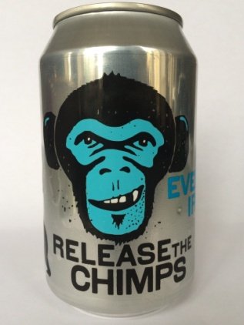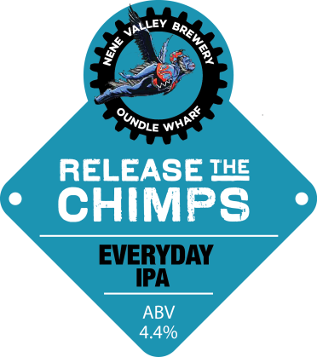
Style | Session IPA
ABV | 4.4%
Tasting Notes | An IPA for everyday drinking. A pale malt base gives a crisp mouthfeel that allows a late addition and dry hops to come through with a punchy bitterness and a good deal of hop flavour in such a light beer.
Description | This is a beer designed to be refreshing and carry a good amount of hop flavour and aroma without necessarily being so strong that it can't be enjoyed all night. The American and Australian hops are added in the steep and as dry hops during the latter stages of fermentation to give a slightly astringent hoppiness which livens the palate but is not overpowering.
Available as | 50l Keg  40l Cask  30l Keykeg  330ml Can
Allergen Info | Gluten Free

