Product Sheet
Big Bang Theory
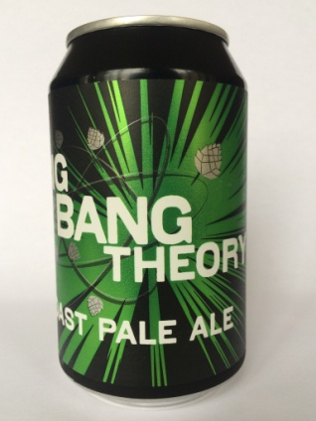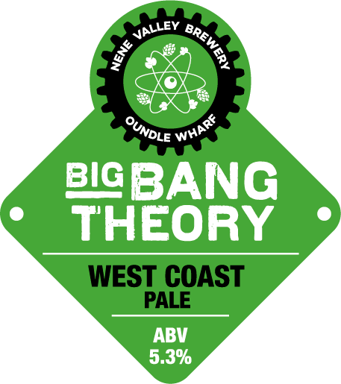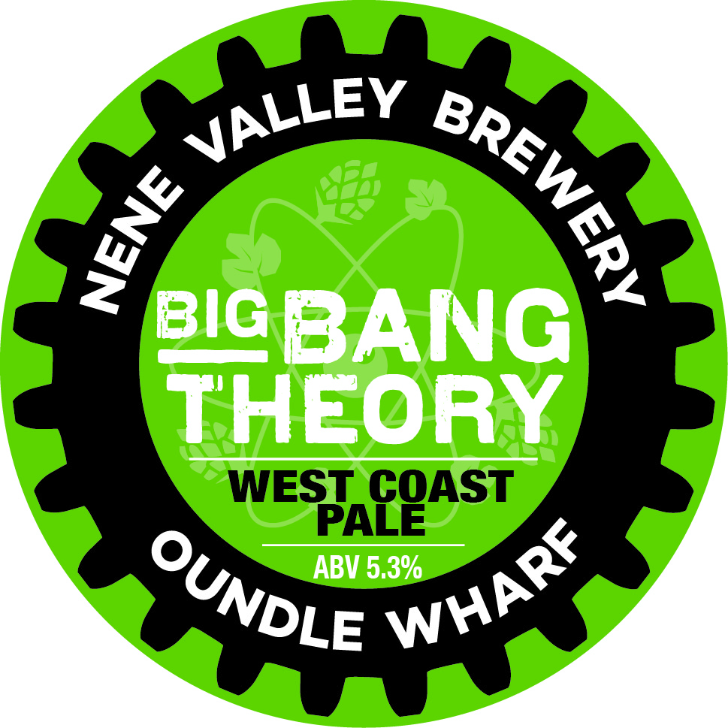
Style | West Coast Pale
ABV | 5.3%
Tasting Notes | Wonderfully balanced pale ale with a huge hop aroma giving way to malty sweetness and a gentle bitter finish
Description | We pack loads an loads of American hops, principally Equanot and Mosaic, into the last stages of the boil and our Hop Accelerator to capture all the hop flavour without creating a hugely bitter beer. The best Maris Otter malt is used and at 5.3% we retain a nice malt flavour which gives us some sweetness and body and improves the overall mouthfeel.
Available as | 50l Keg  40l Cask  30l Keykeg  330ml Can
Allergen Information | Gluten Free

